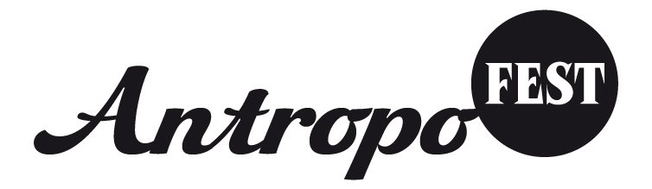
Application form
entering a film in Antropofest 2019

Prague, 25th January – 26th January 2018

Original name of the film
_____________________________________________________________________
Name of the film in English
_____________________________________________________________________

Length ____________________________ Format __________________________

Language of dialogues________________________________________________
Language of subtitles_________________________________________________

Country and year of production________________________________________

Synopsis__________________________________________________________________________________________________________________________________________________________________________________________________________________________________________________________________________________________________________________________________________________________________________________________________________________________________________________________________________________________________________________________________________________________________________________________________________________________________________________________________________________________________________

Director_____________________________________________________________
Contact (e-mail, telephone number, address) __________________________________________________________________________________________________________________________________________
Brief biography ____________________________________________________________________________________________________________________________________________________________________________________________________________________________________________________________________________________
_____________________________________________________________________

Production___________________________________________________________
Contact (e-mail, telephone number, address) __________________________________________________________________________________________________________________________________________

Camera______________________________________________________________
Script_______________________________________________________________
Edit_________________________________________________________________

Launching of the film, awards _______________________________________________________________________________________________________________________________________________________________________________________________________________

Applicant (name)______________________________________________________
Contact (e-mail, telephone number, address) __________________________________________________________________________________________________________________________________________

You can submit your movie via online form at our website and send it via Vimeo, WeTransfer, MyAirBridge etc. You can also send printed application form together with the film on DVD. We accept either classical DVD VIDEO (PAL) or MOV/MP4 (codec H264, SD or HD resolution). We all also need photograph(s) from the film in printing quality together with the movie to the address: Antropofest, Slovinská 994/25, Praha 10, 101 00, Czech Republic. Designate the envelope clearly with the word „Antropofest“. You can also send the photographs from the film by e-mail to festival@antropofest.cz. English subtitles (not only burned in the image) are required - we need it for translation to Czech. We accept only subtitles with exact timing in srt format (created by Subtitle Workshop or other software).

Deadline of applications is October 17th 2018

By entering your film you agree to the following conditions:
- Relevance to the given anthropological themes will be taken into account when choosing the film. Attention will be paid to the content and artistic quality of the film.
- Films of any length will be accepted.
- We prefer movies produced recently.
- By entering his/her film, the owner of the rights gives consent to the film being projected at Antropofest events and archived for the purposes of Antropofest z.s.
- There is no entering fee and no financial reward to applicant, director or producer of the movie.
- Sent DVDs are not returned.
- Photographs and information from the application form will be used for the purposes of the festival (or other event of Antropofest), included in the festival programme/catalogue and posted on the website and social medias of Antropofest. All information will be processing only by members of Antropofest, z.s. and will not be offered to anybody else. More details about protection of personal data are available at our website. Your questions will be respond via our email.
- The deadline for applications is October 17th 2018. Films which arrive after this date will not be included in the projection of the upcoming year of the festival.
- Selected movie will be accompanied by Czech subtitles (if original language is not Czech or Slovak).
- Applicants will be informed about their film being incorporated into the festival programme via e-mail and not later than 20 days before the beginning of the festival.
- Organizers may change place and dates of the festival (at the latest 14 days before start).
- Expenses connected to transporting of film to the address Antropofest Slovinská 994/25, Praha 10, 101 00, Czech Republic or via some cloud will be covered by the applicant.

Name of applicant

_________________________________________________________________

Date, Place_______________________________________________________

Signature ________________________________________________________

